**Department of Information Technology**

**Academic Year: 2024-25 Name of Student:**

**Semester: VI Student ID:**

**Class / Branch / Div: TE- IT A/B/C Roll No.**

**Subject: MAD & PWA Lab Date of Submission:**

**Name of Instructor: Prof Sujata Oak**

**Experiment No.:2**

**Aim:** To design Flutter UI by including common widgets.

**Prerequisites:** Android studio, flutter SDK **.**

**Problem Statement:** To develop a flutter UI for creating student-ID using basic widgets of flutter.

**Software:** Android studio, flutter SDK **.**

**Code:**

**Output:**

import 'package:flutter/material.dart';  
  
void main() {  
 runApp(StudentIDApp());  
}  
  
class StudentIDApp extends StatelessWidget {  
 @override  
 Widget build(BuildContext context) {  
 return MaterialApp(  
 debugShowCheckedModeBanner: false,  
 home: StudentIDCard(),  
 );  
 }  
}  
  
class StudentIDCard extends StatelessWidget {  
 void _displayMyName() {  
 print('Mrs. Sujata Oak');  
 }  
  
 @override  
 Widget build(BuildContext context) {  
 return Scaffold(  
 backgroundColor: Colors.*blueGrey*[50],  
 appBar: AppBar(  
 title: Text('Student ID Card'),  
 backgroundColor: Colors.*blueAccent*,  
 ),  
 body: Center(  
 child: Container(  
 width: 300,  
 padding: EdgeInsets.all(16),  
 decoration: BoxDecoration(  
 color: Colors.*white*,  
 borderRadius: BorderRadius.circular(12),  
 boxShadow: [  
 BoxShadow(  
 color: Colors.*grey*.shade400,  
 blurRadius: 8,  
 spreadRadius: 2,  
 ),  
 ],  
 ),  
 child: Column(  
 mainAxisSize: MainAxisSize.min,  
 crossAxisAlignment: CrossAxisAlignment.center,  
 children: [  
 CircleAvatar(  
 radius: 50,  
 backgroundImage: AssetImage('assets/images/sujataidphoto.jpg'),  
 ),  
 SizedBox(height: 12),  
 Icon(  
 Icons.*email_rounded*,  
 size: 50,  
 color: Colors.*blueAccent*[100],  
 ),  
 SizedBox(height: 12),  
 Text(  
 'Prof Sujata Oak',  
 style: TextStyle(fontSize: 22, fontWeight: FontWeight.*bold*),  
 ),  
 Text(  
 'ID: 351',  
 style: TextStyle(fontSize: 16, color: Colors.*grey*[700]),  
 ),  
 SizedBox(height: 8),  
 Text(  
 'Course: Computer Engineering',  
 style: TextStyle(fontSize: 16),  
 ),  
 Text(  
 'Department: IT',  
 style: TextStyle(fontSize: 16),  
 ),  
 SizedBox(height: 8),  
 Divider(color: Colors.*grey*),  
 Text(  
 'APSHAH Institute of Technology',  
 style: TextStyle(  
 fontSize: 18, fontWeight: FontWeight.*bold*, color: Colors.*blueAccent*),  
 ),  
 SizedBox(height: 12),  
 ElevatedButton(  
 onPressed: _displayMyName,  
 child: Text('Show My Name'),  
 ),  
 ],  
 ),  
 ),  
 ),  
 );  
 }  
}

**OUTPUT:**

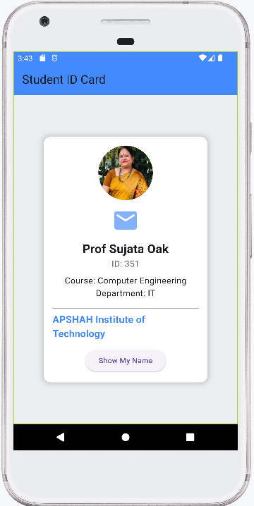

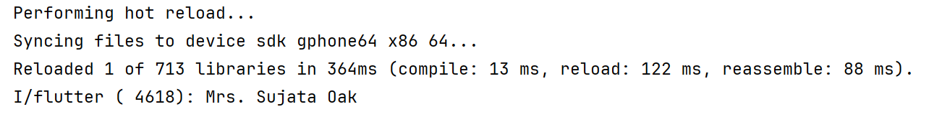

**Conclusion:** In this experiment we have created user interface by using flutter common widgets.